Software Design Document

<Project Name>

Student Names:

Ashley Pergoliti (s5311775)

Jonas Sajonas (s5284977)

Jodie Thomson (s118338)

Table of Contents

1.0 System Vision 3

1.1 Problem Background 3

1.2 System Overview 3

1.3 Potential Benefits 3

2.0 Requirements 4

2.1 User Requirements 4

2.2 Software Requirements 4

2.3 Use Cases & Use Case Diagrams 5

3.0 Software Design and System Components 6

3.1 Software Design 6

3.2 System Components 6

3.2.1 Functions 6

3.2.2 Data Structures / Data Sources 6

3.2.3 Detailed Design 6

4.0 User Interface Design 7

4.1 Structural Design 7

4.2 Visual Design 7

# System Vision

*Can incorporate maybe*

*This project will design and develop the software that reads data from the data set, performs user defined functions on the data and displays the results in a purpose-designed user interface. The capabilities will include:*

* *A search option that will allow a user to find listings targeting specific suburbs.*
* *For a user specified period, output a chart showing price distribution.*
* *For a user specified period and keywords, output records.*
* *Analysis of cleanliness from customer comments.*
* *Output charts showing variances in availability and associated pricing across the year - TBC*

## Problem Background

Excel sheets are widely used to store large sets of text data. Users face problems when trying to view these large sets of data. This can be due to there being many unnecessary sections of data. This makes it hard for a user to sort through the data for what they are looking for.

This applies to users trying to view data relating to Airbnb. Users want to pick a specific date and see information about different properties. This information includes the distribution of prices, listings by a specific suburb, records including user chosen keywords, and customers that commented on the cleanliness of the property.

It is recommended that a system is created to help these users view the data quickly and effectively.

## System Overview

This system should be able to complete the following:

* Create a user interface that has interactable buttons and input fields that change what is displayed on the interface.
* Read different CSV files.
* Display different data based on the

## Potential Benefits

This system will provide the following benefits for the users:

* View large sets of data through a smooth user-friendly interface.
* View this data in text form and graph form.
* Filter through the data for their specific chosen criteria.
* Speed up the process of analysing the data.

# Requirements

## User Requirements

* Run the GUI script.
* Select a specific date period.
  + See the information of all suburbs listed under this date.
  + Able to view a chart that is created, which shows the distribution of prices of properties.
  + Able to enter a specific keyword to view all records that contain that keyword.
* Able to view and analyse places where customers have commented on the cleanliness of the Airbnb. ??
* Another unnamed “insight” or analysis tool of our choice. ??

In this section you detail how a user is supposed to interact with or use your program. What do they ***need*** to be able to do? This should all be from the end users perspective. Can be a combination of narrative text and listing of needs.

**Assignment note: You have not been given a client/user, so you can make one up. Who do you think would be using your software?**

## Software Requirements

In this section you detail what the requirements for the software are. What functionality will it provide? This is usually a formal listing, with requirements often using the word ‘Shall’. IE:

R1.1 The program shall accept multiple file names as arguments from the command line.

R1.2 Each file name can be a simple file name or include the full path of the file with one or more levels.

etc …

Can be primarily functional requirements, though you may include other types if you think of them.

* The program shall be run as a single file in the command line.
* The script shall open to a GUI interface.
* The GUI interface shall have several buttons and other input fields that the user can interact with.
* These buttons shall trigger further actions and interfaces- a graph.

(Check

Required Features:

For a user-selected period, report the information of all listings in a specified suburb

For a user-selected period, produce a chart to show the distribution of prices of properties

For a user-selected period, retrieve all records that contain a keyword (user entered), e.g. pool, pet.

Analysing how many customers commented on factors related to cleanliness (multiple key words may be associated with cleanliness – justify your selection).

***OTHER OPTIONS: One other ‘insight’ or analysis tool of your choice)***

***busist or quietest time – availabilty – chart year?***  
***lowest price time of year***  
***Most options to choose?***

## Use Cases & Use Case Diagrams – need 2-3

* In this section you provide some use cases showing how people may use your software.  
  *A search option that will allow a user to find listings targeting specific suburbs.*
* *For a user specified period, output a chart showing price distribution.*
* *For a user specified period and keywords, output records.*
* *Analysis of cleanliness from customer comments.*
* *Output charts showing variances in availability and associated pricing across the year - TBC*

Beginning of use case diagram – idk if this is even close

https://lucid.app/lucidchart/05a101cd-3e34-424d-ae05-a2dfcf43707b/edit?viewport_loc=-1222%2C42%2C2758%2C1295%2C0_0&invitationId=inv_53257447-7ef1-422e-ac89-3be62abd9110

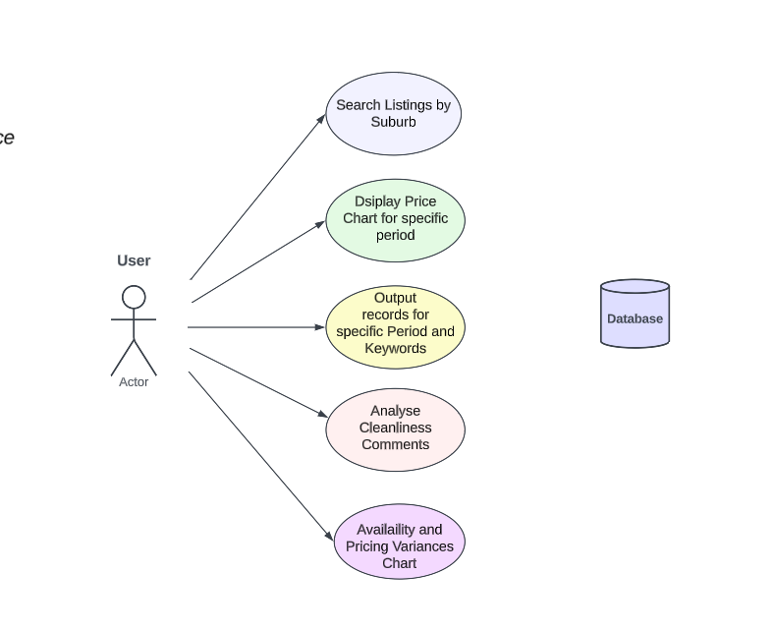

|  |  |
| --- | --- |
| **Element** | **Description** |
| Use Case ID | 1.0 |
| Use Case Name | Select Date ? |
| Primary Actor | User |
| Description | The user picks a date. |
| Pre-Condition | The user opens the GUI script. |
| Post-Condition | The user can open graphs?? |
| Success Scenario | Data is displayed for the picked date. |
| Abort Scenario | Data is not displayed. |

Drafts:

|  |  |
| --- | --- |
| **Element** | **Description** |
| Use Case ID | 2.0 |
| Use Case Name | Report information of all listings in a suburb |
| Primary Actor | User |
| Description | The user picks a date.? |
| Pre-Condition | The user opens the GUI script. |
| Post-Condition | A list of all the airbnb in a suburb |
| Success Scenario | Data is displayed |
| Abort Scenario | Data is not displayed. |

|  |  |
| --- | --- |
| **Element** | **Description** |
| Use Case ID | 3.0 |
| Use Case Name | Show price distribution chart |
| Primary Actor | User |
| Description | The user picks a suburb? |
| Pre-Condition | The user picks a suburb |
| Post-Condition | The script opens a chart |
| Success Scenario | The user is shown a chart of prices in a suburb |
| Abort Scenario | Data is not displayed. |

|  |  |
| --- | --- |
| **Element** | **Description** |
| Use Case ID | 4.0 |
| Use Case Name | Retrieve all records that contain a keyword |
| Primary Actor | User |
| Description | The user provides a keyword in the searchbar |
| Pre-Condition | The user opens the GUI script. |
| Post-Condition | The user can open graphs?? |
| Success Scenario | Data is displayed for the picked keyword. |
| Abort Scenario | Data is not displayed. |

|  |  |
| --- | --- |
| **Element** | **Description** |
| Use Case ID | 5.0 |
| Use Case Name | Customer comments |
| Primary Actor | User search for comments related to cleanliness |
| Description | The user searches for comments related to cleanliness |
| Pre-Condition | User filters the comments about cleanliness |
| Post-Condition | The GUI shows comments up to 10 most recent |
| Success Scenario | The data shows 10 comments that relates to cleanliness |
| Abort Scenario | Data is not displayed. |

# Software Design and System Components

## Software Design

A block diagram/flowchart of how your software might work

## System Components

### Functions

Preliminary list of all functions in the software. For each function in the list the following information is provided:

* a brief description of what it does (1 or 2 sentences);
* a list of the input parameters, and their data types, and what they are used for;
* a list of any side effects caused by the function (ie change global or member variables, changes data passed by reference from calling function etc)
* a description of the function’s return value
* def readExcel()
  + A function that will be used to read the CSV files to grab the data.
  + Returns the dataframe of the data. This is a data representation of the CSV file.
* def selectdDate()
  + A function that will grab the date from the user-selected period.

### Data Structures / Data Sources

List of all data structures in the software (eg linked lists, trees, arrays etc) or eternal data sources. For each data structure in the list the following information is provided:

* Type of structure (tree, list etc),
* Description of where and how it is used
* List of data members, and what each one is for do
* List of functions that use it

### Detailed Design

Pseudocode for all non-standard / non-trivial algorithms that operate on data structures

# User Interface Design

This is your initial interface design. Describe the tools you used for this design stage and any key findings that informed your design. This introduction is descriptive and should explain what you have completed for the actual design work you will present in the sub-sections below.

## Structural Design

Structural design refers to the navigational and information structure of your product – the structure that supports the interface layout. How will you structure your product? How will you group your information? How will you navigate through your product? Why? This can take the form of a diagram showing structure and hierarchy, supported by a discussion and justification of your choices. Why have you made these design choices? Describe and outline the structure of your interface and of your information.

## Visual Design

Detail your visual design: Layout, visual elements, icons, graphics, style, colour, fonts general screen designs. This can be sketches, wireframes, mockups etc, supported by a discussion, explanation, and justification of your choices.